EXPERIMENT 5
ROLL NO: 240701533 NAME: SRITHIKA S

Conduct task analysis for an app and document user flows. Create corresponding wireframes using Lucidchart
Screen 1:
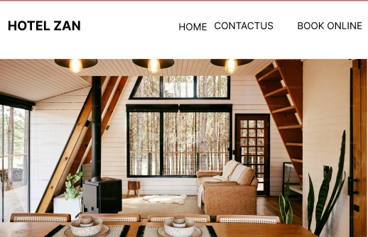

The image shows the homepage of a hotel website called “HOTEL ZAN.”
At the top, there is a navigation bar with options: Home, Contact Us, and Book Online, which help users move to different pages.
Below the navigation bar, a large hero image displays the interior of the hotel, creating a good first impression and showing the hotel’s ambience.
The design is simple, clean, and user-friendly, allowing visitors to easily explore the website and book rooms online.
PROTO TYPE LINK:
https://www.figma.com/design/m0HQMKrgyKcmFK1nSLieen/Untitled?node-id=30-2
Screen 2:
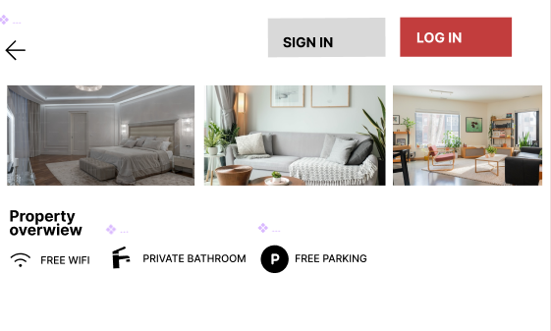
This screen shows the property overview page of the HOTEL ZAN website/app.
- At the top, there is a back arrow and two buttons: Sign In and Log In for user authentication.
- The middle section displays images of hotel rooms/interiors to show the property.
- The bottom section provides property features, such as Free WiFi, Private Bathroom, and Free Parking.
The page helps users view the hotel facilities and decide whether to book the room.
PROTO TYPE:
https://www.figma.com/design/m0HQMKrgyKcmFK1nSLieen/Untitled?node-id=30-23

Screen 3:
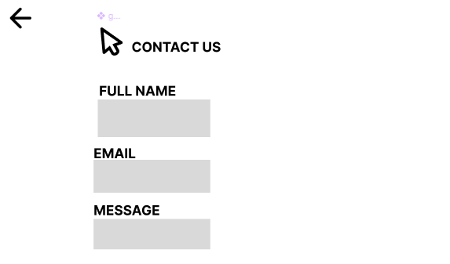
This screen shows the Contact Us page of the HOTEL ZAN website/app.
- At the top, there is a back arrow to return to the previous page.
- The page title “Contact Us” indicates the user can send inquiries.
- It contains a form with three fields: Full Name, Email, and Message.
This page allows users to submit questions, feedback, or requests to the hotel.

PROTOTYPE LINK:
https://www.figma.com/design/m0HQMKrgyKcmFK1nSLieen/Untitled?node-id=31-16
LUCID CHART:
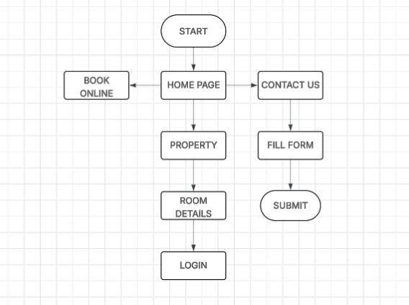

This diagram shows the website flow (Lucidchart) of the HOTEL ZAN website.
- The process starts at Start and moves to the Home Page.
- From the Home Page, users can choose three options:
  - Book Online to reserve a room.
  - Contact Us, where users fill a form and submit their message.
  - Property, where users view room details and then log in to continue.
The flowchart explains how users navigate through the hotel website pages

